DRAGONFLY

Structural Analysis Report

Rev. H: 28/05/2024

Kyushu Institute of Technology

BIRDS-X project

Revision History

|  |  |  |  |
| --- | --- | --- | --- |
| Version | Date | Writer | Annotations |
| NC | 20/09/2023 | Jorge Casir | Initial Release |
| A | 14/12/2023 | Jorge Casir | Structural change |
| B | 22/12/2023 | Jorge Casir | Adjusted simulation |
| C | 26/12/2023 | Jorge Casir | Added STR-08 results/ Fixed comments |
| D | 29/01/2024 | Hoksong Tim | Fixed page in table of content |
| E | 29/03/2024 | Jorge Casir | Ballistic Number Result |
| F | 19/04/2024 | Yudai Etsunaga | SFCB Fixes |
| G | 09/05/2024 | Yudai Etsunaga | SFCB Fixes |
| H | 28/05/2024 | Yudai Etsunaga | SFCB Fixes |

Content

1. Purpose 4

2. Applicable Document 4

3. Abbreviations and Acronyms 4

4. Structural Design 5

5. Analysis Model 13

5.1. Mass Characteristic 13

5.2. Ballistic Number 14

5.3. Vent Hole Analysis 14

5.4. Finite Element Modelling (FEM) 16

5.5. Analysis result 19

5.5.1. Natural Frequency Analysis 19

5.5.2. Static Load Analysis 20

5.5.3. Fastener Analysis 24

6. Structure Fracture Control 38

6.1. Potentially Fracture Critical Parts Identification 38

6.1.1. Contained Parts 38

6.1.2. Fail-Safe Parts 38

6.1.3. Low-Risk Fracture Parts 38

6.1.4. Sealed Container 38

6.1.5. Fracture Critical Parts 38

6.1.6. Pressurized System 39

6.1.7. Pressurized vessel 39

6.1.8. High Energy Rotating Machinery 39

6.2. Inspection for Safety Critical Structures 39

6.3. Inspection After Test 39

7. Discrepancy or Anomaly Reports 39

8. Material Usage Agreements for Stress Corrosion Cracking Material 39

9. Conclusions 39

# Purpose

This document summarizes the structural analysis and fracture control results for DRAGONFLY satellite, which will be deployed from JEM Small Satellites Orbital Deployer (J-SSOD).

# Applicable Document

1. JX-ESPC-101132-E JEM Payload Accommodation Handbook-Vol.8-

Small Satellite Deployment Interface Control Document

**Section 2.1. Mechanical Interfaces**

2.1.5. Mass Properties

2.1.6. Separation Spring

2.1.8. Structural Strength

2.1.9. Stiffness

**Section 2.4. Environmental Requirements**

2.4.1. Random Vibration and Acceleration

2.4.2. On-orbit Acceleration

2.4.3. Pressure Environment

2.4.4. Thermal Environment

1. JMX-2012694　 Structure Verification and Fracture Control Plan

for JAXA Selected Small Satellite Released from J-SSOD

**Section 6. Fracture Control Plan**

**Section 7. Structure Verification Plan**

7.1. Analysis (applied to the satellite main structure)

7.2 Strength tests

# Abbreviations and Acronyms

CAD Computer-Aided Design

COTS Commercial Off-The-shelf

FEA Finite Element Analysis

FEM Finite Element Method

FS Factor of Safety

ISS International Space Station

J-SSOD JEM Small Satellite Orbital Deployer

JEM Japanese Experiment Module

MIUL Materials Identification Usage List

MS Margin of Safety

MUA Material Usage Agreement

NASA National Aeronautics and Space Administration

SAR Safety Assessment Report

COM Communicator

JAXA Japan Aerospace Exploration Agency

MCU Micro Control Unit

MS Margins of Safety

MUA Material Usage Agreement

NDE Non-destructive Evaluation

PIC Peripheral Interface Controller

# Structural Design

DRAGONFLY is a 2U CubeSat whose structure is made of 4 rails and 3 frames. 4 rods support the internal configuration of the satellite. Figures 4-1 and 4-2 show the structural analysis model of DRAGONFLY, Figure 4-3 shows the main structure, and Figure 4-4 shows the internal structure. The dimensions of the satellite are 100 mm × 100 mm × 227 mm, and the mass is 1758 g. The external panel of the satellite consists of an upper panel (+Z), six side panels (+X, -X, +Y/+Z, +Y/-Z, -Y/+Z, -Y/-Z), and a bottom panel (-Z) that are mounted to the structure’s main frame. DRAGONFLY's 4 Rails shall be made of anodized aluminum (A6061-T6) 3 frames made of aluminum (A6061-T6) with alodin treatment after machining, and 4 stacking rods made of SUS304. Two solar cells are mounted on the +Y/-Z, -Y/+Z, and the -Z and +Z external panels of the CubeSat. Four solar cells are mounted on the +X and -X external panels. The access ports are on the –Z and +X faces. A separation spring and 3 deployment switches are mounted on the rail standoffs on the –Z face of the CubeSat. M2 fasteners will be used for constraining the structure of the main frame and constraining the external frame with each panel. Also, two deployable antennas are mounted on the +Y/+Z and -Y/-Z panels.

Table 4-1 shows the list of parts of DRAGONFLY for structure analysis and fracture control.

**Table 4-1 Parts list for structure analysis and fracture control**

|  |  |  |  |  |  |
| --- | --- | --- | --- | --- | --- |
| **No** | **Part Name** | **Part No.** | **Material** | **Qty** | **Remarks** |
| 1 | Frame -Z | Structure-01 | A6061-T6 | 1 |  |
| 2 | Frame 0Z | Structure-02 | A6061-T6 | 1 |  |
| 3 | Frame +Z | Structure-03 | A6061-T6 | 1 |  |
| 4 | Rail (-Y/-X) | Structure-04 | A6061-T6 | 1 |  |
| 5 | Rail (+Y/-X) | Structure-05 | A6061-T6 | 1 |  |
| 6 | Rail (+Y/+X) | Structure-06 | A6061-T6 | 1 |  |
| 7 | Rail (-Y/+X) | Structure-07 | A6061-T6 | 1 |  |
| 8 | +Z Panel | +Z Panel | FR4 | 1 |  |
| 9 | -Z Panel | -Z Panel | FR4 | 1 |  |
| 10 | -Y/-Z Panel (Antenna 1) | -Y/-Z Panel | FR4 | 1 |  |
| 11 | -Y/+Z Panel | -Y/+Z Panel | FR4 | 1 |  |
| 12 | +Y/+Z Panel (Antenna 2) | +Y/+Z Panel | FR4 | 1 |  |
| 13 | +Y/-Z Panel | +Y/-Z Panel | FR4 | 1 |  |
| 14 | +X Panel | +X Panel | FR4 | 1 |  |
| 15 | -X Panel | -X Panel | FR4 | 1 |  |
| 16 | -Y Cover | -Y Cover | FR4 | 1 |  |
| 17 | +Y Cover | +Y Cover | FR4 | 1 |  |
| 18 | Battery | Component-01 | NiMH | 6 |  |
| 19 | Battery Box | Component-02 | A6061-T6 | 1 |  |
| 20 | Battery Box Cover | Component-03 | A6061-T6 | 1 |  |
| 21 | Battery Insulator | Component-04 | Teflon | 1 |  |
| 22 | Stacking Rod | Component-05 | SUS304 | 4 | All PCBs are fixed to  these rods. The rods are fastened to Structure Main Frame. |
| 23 | Spacer | Component-06 | MC Nylon | 56 |  |
| 24 | Antenna deployment mechanism 1 | Component-07 | Teflon | 1 | Contained by fishing wire |
| 25 | UHF Antenna | Component-08 | SK85 | 4 |  |
| 26 | VHF Antenna | Component-09 | SK85 | 4 |  |
| 27 | Rear Access Board | Component-10 | FR4 | 1 |  |
| 28 | New COM Board | Component-11 | FR4 | 1 |  |
| 29 | APRS R-1 Board | Component-12 | FR4 | 1 |  |
| 30 | APRS R-2 Board | Component-13 | FR4 | 1 |  |
| 31 | APRS P-1 Board | Component-14 | FR4 | 1 |  |
| 32 | APRS P-2 Board | Component-15 | FR4 | 1 |  |
| 33 | APRS P-3 Board | Component-16 | FR4 | 1 |  |
| 34 | APRS P-4 Board | Component-17 | FR4 | 1 |  |
| 35 | APRS P-5 Board | Component-18 | FR4 | 1 |  |
| 36 | COM Board (Addnics Transceiver) | Component-19 | FR4 | 1 |  |
| 37 | OBC/EPS Board | Component-20 | FR4 | 1 |  |
| 38 | Front Access Board | Component-21 | FR4 | 1 |  |
| 39 | Back Plane Board | Component-22 | FR4 | 1 |  |
| 40 | Solar Cell | Component-23 | Glass | 16 |  |
| 41 | Fastener (Screw) | Fastener-01 | SUS304 | 92 |  |
| 42 | SLBNR3 (Nut) | Fastener-02 | SUS304 | 4 |  |
| 43 | Fishing Wire | Wire | PE line | 4 |  |
| 44 | Heat cutter | Heat cutter | Nichrome | 2 |  |
| 45 | Antenna deployment mechanism 2 | Component-24 | Teflon | 1 | Contained by fishing wire |
| 46 | Deployment Switch Cover (L-shape) | Structure-08 | A6061-T6 | 3 |  |
| 47 | Hexagon Nut M2 | Fatener-03 | SUS304 | 16 |  |

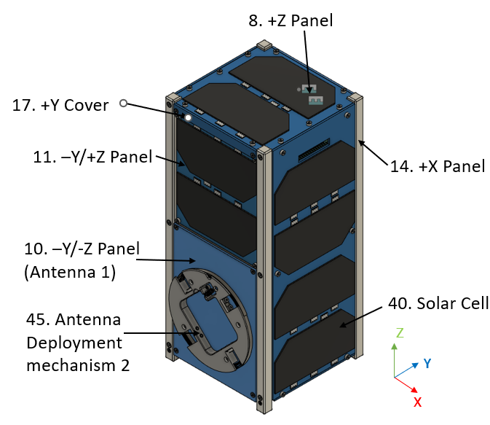

**Figure 4-1 Overview of the Satellite (Before Deployment)**

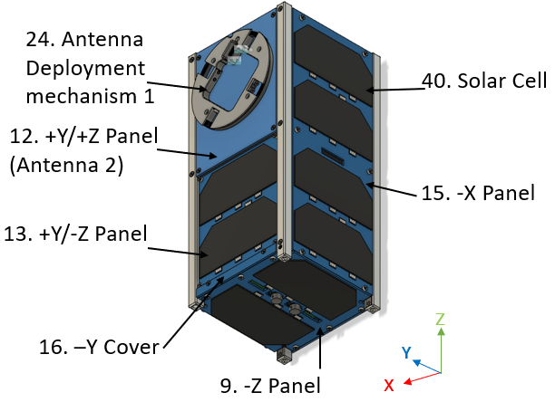

**Figure 4-2 Overview of the Satellite (Before Deployment)**

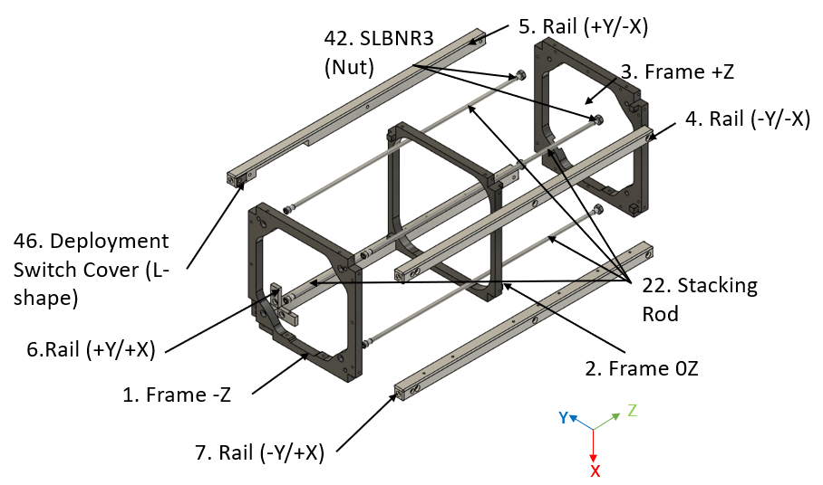

**Figure 4-3 Satellite Structural Parts**

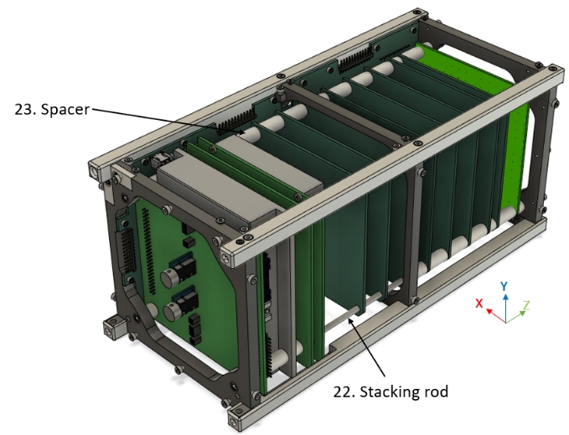

**Figure 4-4 Overall Satellite Internal Configuration**

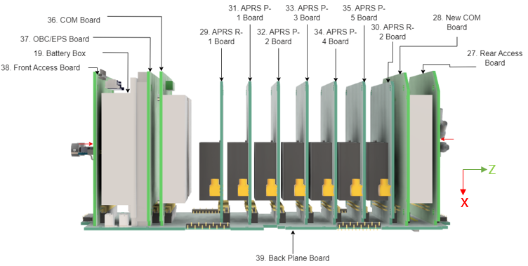

**Figure 4-5 Satellite Internal Subsystems**

**Figure 4-6 Battery Configuration of Satellite**

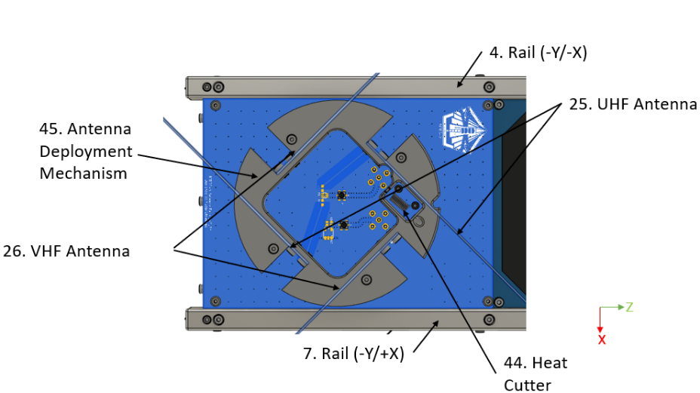

1. **Deployed**

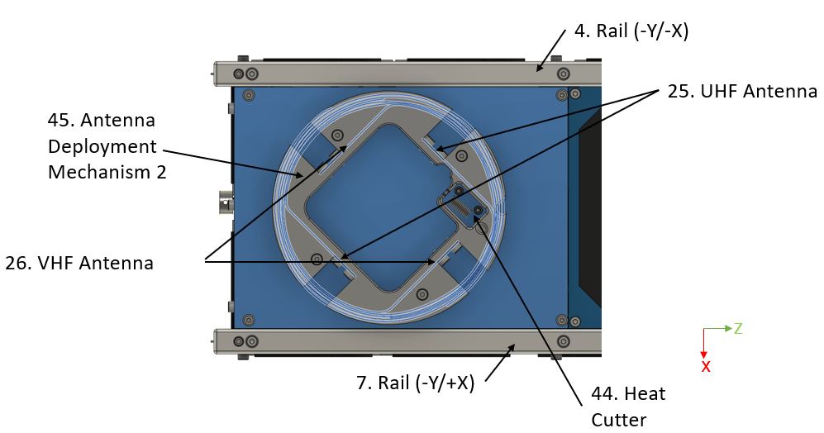

**(b) Stowed**

**Figure 4-7 Antenna Deployment System 1 on the -Y/-Z panel**

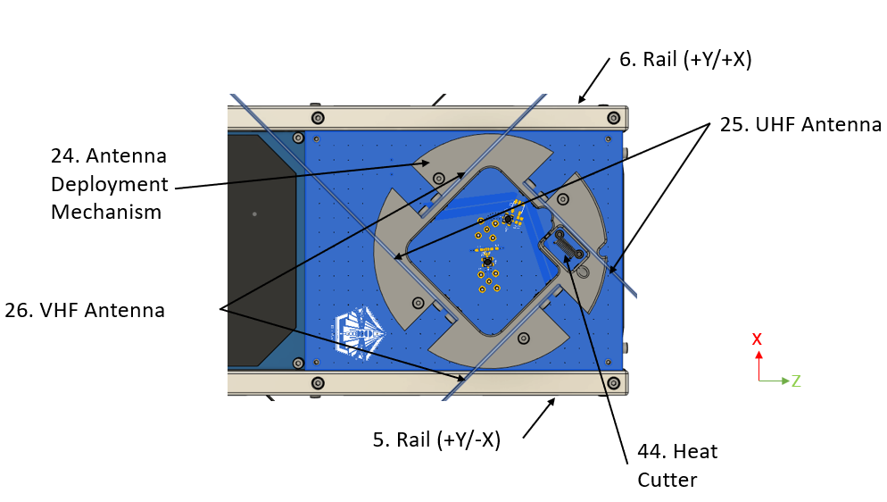

1. **Deployed**

1. **Stowed**

**Figure 4-8 Antenna Deployment System 2 on the +Y/+Z panel**

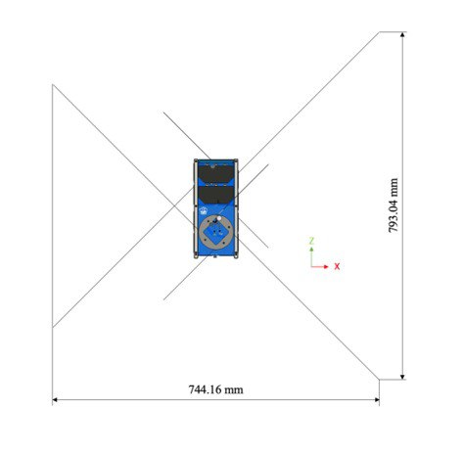

**Figure 4-9 Deployed View of the Satellite**

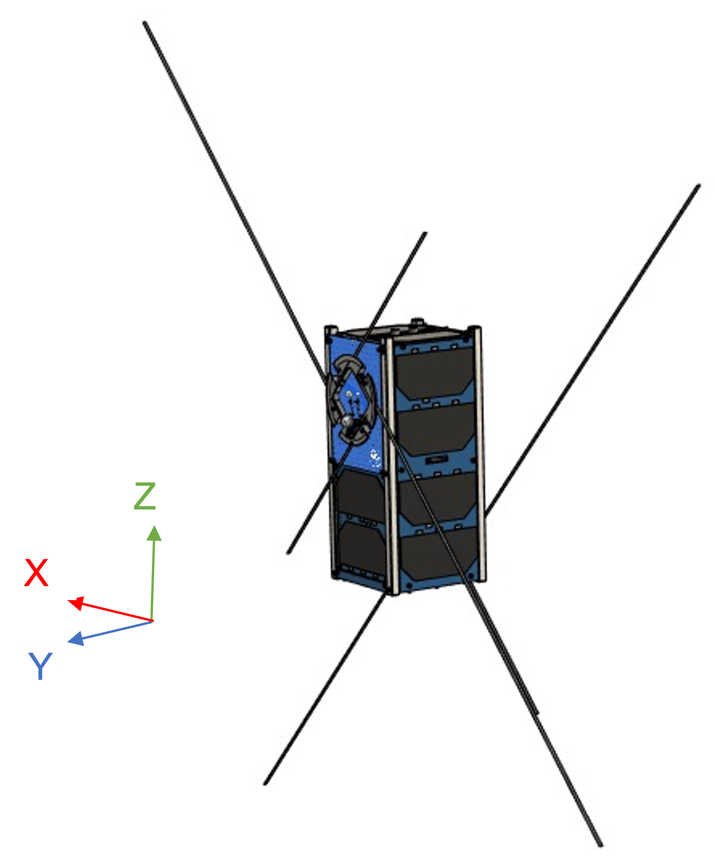

**Figure 4-10 Deployed View of the Satellite**

**Table 4-2 Safety critical parts check list**

|  |  |  |  |  |
| --- | --- | --- | --- | --- |
| **No** | **Component** | **Qty** | **Covered?**  **(yes/no)** | **Remarks** |
| 1 | Solar Cell Cover Grass | 16 | No |  |
| 2 | Battery cell | 6 | Yes | Covered for electrical insulation |
| 3 | Deployment Mechanism | 2 | No | Two (inside) of the four dipole antennas are restrained by another antennas (outside). Two outer antennas are restrained by two strings each. |
| 4 | Wire | 4 | - | Since the deployment mechanism is hazard, the wire is redundant. |
| 5 | Fastener | 108 | No | Loctite will be applied.  Torque mark shall be checked after vibration test. |

# Analysis Model

## Mass Characteristic

The actual measured satellite mass is 1,758 g, as shown in Fig5.1-1.

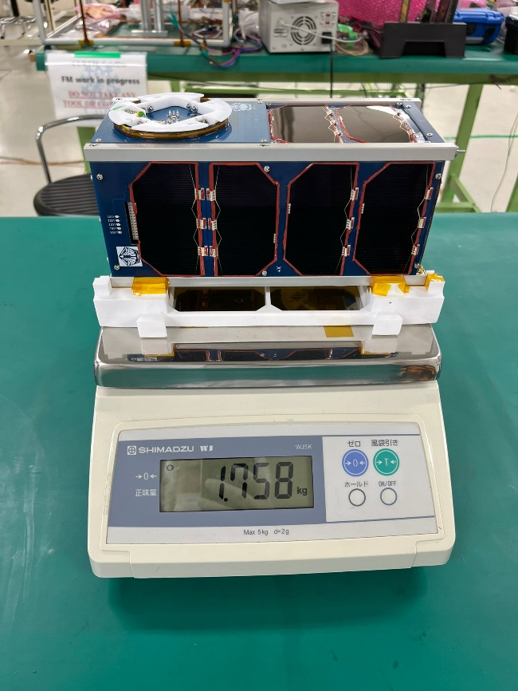

**Figure 5.1-1 Mass characteristic**

## Ballistic Number

Requirement: Ballistic Number (BN) shall be less than 115 kg/m2. The BN is calculated using the equation below. The maximum BN for this satellite satisfies the requirement.

$$BN=\frac{m}{C_{d}∙A}\left[{kg}/{m^{2}}\right]=\frac{1.758}{2*0.018}=48.833\left[{kg}/{m^{2}}\right]<115 \left[{kg}/{m^{2}}\right],$$

where

$C_{d}$ is the drag coefficient = 2;

$A$ is the average area of satellite in XY, YZ, ZX = 0.018m2 (XY = 0.100 × 0.100, YZ = ZX = 0.227 × 0.100)

$m$ is the maximum predicted satellite mass = 1.758 kg.

## Vent Hole Analysis

In DRAGONFLY, there is a hole through the +X panel, and it functions as a vent hole. There are other vent holes also. Figures 5.3-1 and 5.3-2 show the Vent Holes of DRAGONFLY in +X panel, -X panel and –Z panel. By using the internal volume, *V* = 980.7 cm3 and the effective vent area, *A* = 5.9 cm2, can be expressed as following equation:

$$+X plane:A_{+X}=31∙5.7=176.7 {mm}^{2}$$

$$-Z plane:A_{-Z}=17.5∙4+16∙4+14∙5∙2+8.5∙1.5∙2=299.5 {mm}^{2}$$

$$-X plane:A_{-X}=22.6∙5=113 {mm}^{2}$$

$$A=A_{+X}+A_{-Z} + A_{-X}=176.7+299.5+113=589.2 {mm}^{2}=5.9 {cm}^{2}$$

$$\frac{V}{A}=\frac{980.7 {cm}^{3}}{5.9 {cm}^{2}}≈166.2 cm≤5080 cm$$

DRAGONFLY satisfies a requirement of Section 2.4.3 in the applicable document (a), which is $V/A≤50.8 \left[m\right]\left(=2000 \left[in\right]\right).$ The pressure environment is not considered in this analysis.

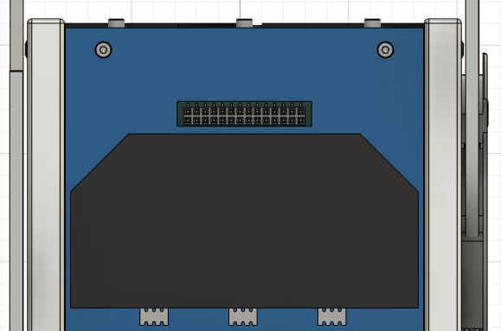

**31 × 5.734**

**Figure 5.3-1 Vent Hole (+X)**

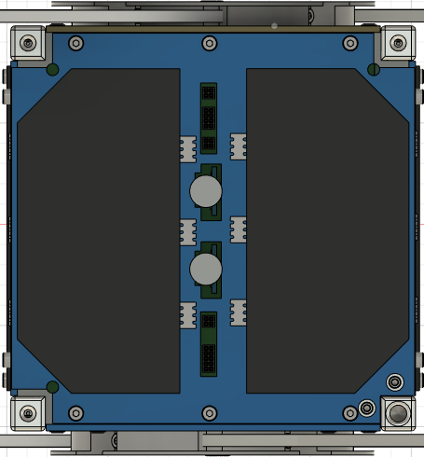

**4 × 16**

**4 × 17.5**

**5 × 14 + 1.5 × 8.5**

**Figure 5.3-2 Vent Hole (-Z)**

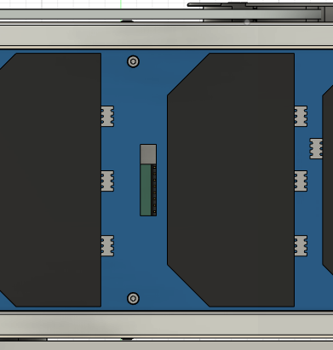

**22.6 × 5**

**Figure 5.3-3 Vent Hole (-X)**

## Finite Element Modelling (FEM)

The Finite element model (Figures 5.4-1 to 5.4-3) of the structure was created by using Fusion360TM software. The mass properties were used to construct a model with approximately equal mass as the components. The model was simplified by using basic rectangular shapes to model the different masses. A global glued contact was used to eliminate complexities created by screws and complex geometry. Actual Material properties were used for the four materials (A6061-T6, FR4, SUS304, MC Nylon and Teflon. The structure was modified by removing fillets and holes (to make meshing easy).

All internal components that are not located on the main load path are replaced with a simulated point mass inside the structure. This mass is located at the center of the simulated component. The mass is connected to the main structure by the same method as the flight model.

* The mass of external components outside of the main structure, such as solar cells, are added as simulated point mass to the screws, which fastens the external components;
* A global bonded contact is used at the thread face of fasteners to eliminate complexities created by screws and complex geometry. A frictionless sliding contact is used at the other boundary between each component. J-SSOD is not considered in FEM;
* The structure is modified by removing fillets and holes to simplify meshing;
* Actual material properties are used for the materials;
* The axial load of the fastener made by the initial torque value is applied as a tensile force at the end face of each fastener. The axial load used in the analysis model is selected from Table 5.4-1.

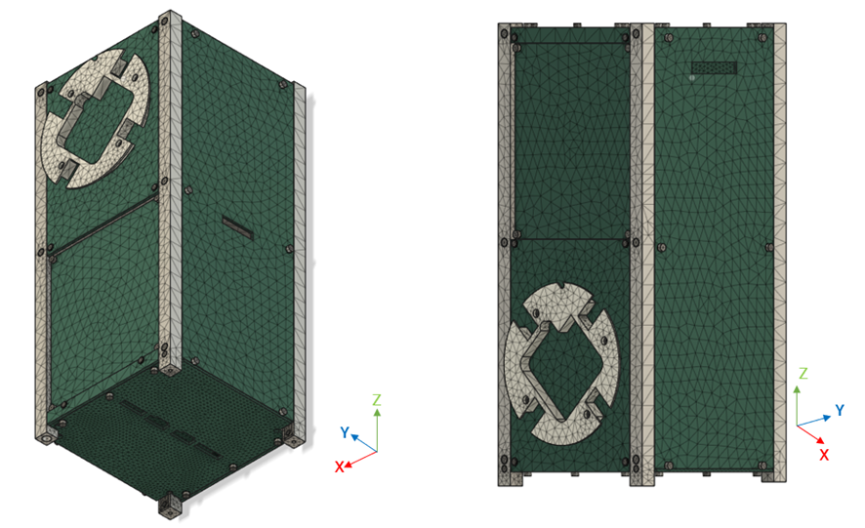

**Figure 5.4-1 Finite Element Model**

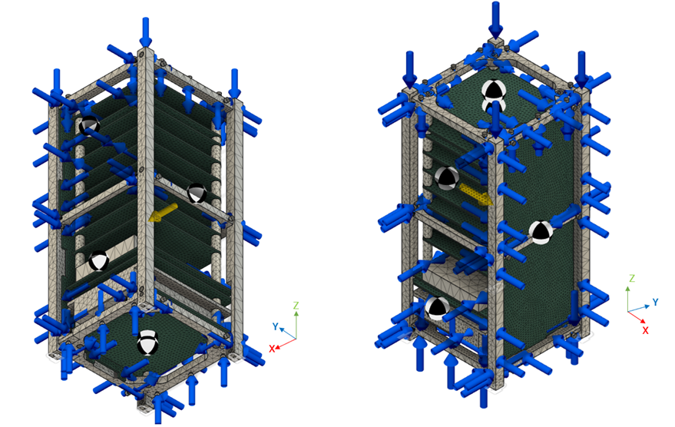

**Figure 5.4-2 Finite Element Model**

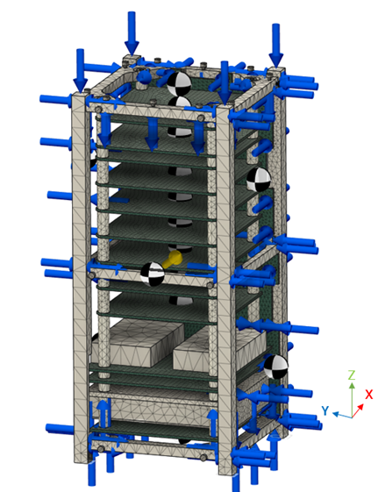

**Figure 5.4-3 Finite Element Model**

**Table 5.4-1 Material Properties of DRAGONFLY Satellite Components**

|  |  |  |  |
| --- | --- | --- | --- |
| **Material** | **Ultimate Tensile Stress (MPa)** | **Yield Stress (MPa)** | **Data Source** |
| A6061-T6 | 310 | 276 | https://www.matweb.com/search/DataSheet.aspx?MatGUID=b8d536e0b9b54bd7b69e4124d8f1d20a&ckck=1 |
| FR4 | 270 | - | https://hirosugi.co.jp/technical/material/GG.html |
| SUS304 | 505 | 215 | https://www.matweb.com/search/DataSheet.aspx?MatGUID=abc4415b0f8b490387e3c922237098da&ckck=1 |
| Teflon | 27.5 | - | https://ptfe-machinery.com/properties-ptfe-insulating-materials/ |
| MC Nylon | 96 | - | https://us.c.misumi-ec.com/book/usa_2019_msm_fa/digitalcatalog.html?page_num=2019-2333 |

The axial load of the fastener made by the initial torque value is applied at the thread of fastener as tensile force

Global Bonded Contact

Frictionless bsliding contact

The axial load of the fastener made by the initial torque value is applied at the “neck” of the fastener head as tensile force

**Figure 5.4-4 Input Condition of Axial Load**

**Table 5.4-2 Axial Load of Fastener**

|  |  |  |  |
| --- | --- | --- | --- |
| **Type** | **Effective Cross-Sectional Area [mm2]]** | **Initial torque [Nm]** | **Axial load [N]** |
| M2 | 2.07 | 0.176 | 440 |
| M2  (Ultra-low head screw) | 2.07 | 0.160 | 400 |
| M1.6 | 1.27 | 0.086 | 280 |

**Table 5.4-3 Constraint Condition**

|  |  |  |
| --- | --- | --- |
| Natural Frequency Analysis | -Z face of rails | Fixed Geometry (fixes translations) |
| +Z face of rails | Fixed Geometry (fixes translations) |
| The surface of rails contacted with  J-SSOD | No constraint |
| Thread face / contacted material | Global bonded contact |
| Boundary condition between other materials | Frictionless sliding contact |
| Static Load Analysis  /Fastener Analysis | -Z face of rails | Fixed Geometry (fixes translations) |
| +Z face of rails | No constraint* |
| The surface of rails contacted with  J-SSOD | No constraint |
| Thread face / contacted material | Global bonded contact |
| Fastener head / contacted material | Global bonded contact |
| Boundary condition between other materials | Frictionless sliding contact |

* Fixing X and Y axes is also acceptable

FEM Loading: The analysis was done under the following conditions:

1. Using the quasi-static acceleration levels of Cygnus (9G), the model was subjected to a gravity load of 9G (88.29 ms-2) in the plane with the launch axis (1G = 9.81 ms-2);
2. An axial force equal to 46.6 N is applied on each rail;
3. Each rail is rigidly constrained at the base (- Z axis).

Stress levels on various parts of the satellite are displayed in Table 5.4-4 and using a factor of safety of 1.5 for yield and 2 for ultimate stress (Ftu).

**Table 5.4-4 Load Applied on FEM**

|  |  |  |  |
| --- | --- | --- | --- |
| **Case ID** | **Acceleration level [G]** | | |
| **X-axis** | **Y-axis** | **Z-axis** |
| Compressive Load |  |  | 46.6 N |
| STA1 | 9 | - | - |
| STA2 | - | 9 | - |
| STA3 | - | - | 9 |

## Analysis result

### 5.5.1. Natural Frequency Analysis

Analysis Conditions:

Both ends of 4 rails are constrained rigidly based on Section 2.1.9 in the applicable document (1).

FEM Results:

Analysis by Fusion360TM has revealed that the minimum fundamental frequency of DRAGONFLY is 258.4 Hz. As the minimum fundamental frequency of 258.4 Hz is much higher than 30 Hz, it can be said that DRAGONFLY satisfies the requirement for rigidity. Table 5.5.1-1 shows the frequency of each axis, and Figure 5.5.1-1 shows movements at the minimum frequency.

**Table 5.5.1-1 Natural Frequency of Each Axis**

|  |  |
| --- | --- |
| **Axis** | **Frequency [Hz]** |
| X | 258.4 |
| Y | 273.8 |
| Z | 293.1 |

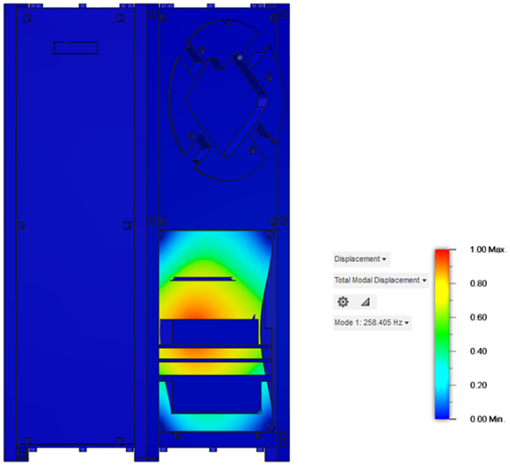

**Figure 5.5.1-1 Natural Frequency (258.4 Hz)**

### 5.5.2. Static Load Analysis

FEM Results:

Stress levels on various parts of the satellite are displayed in Tables 5.5.2-1 to 5.5.2-3. Figures 5.5.2-1 to 5.5.2-3 show the FEM with input load, acceleration, and constraint condition for each analysis case. The margin of safety (MS) for the various components was computed using a factor of safety (FS) of 1.5 for yield strength (Fty) and 2.0 for ultimate strength (Ftu). These values can include the factors of safety for Non-HTV-X and HTV-X.

$$MS=\frac{Allowable Stress}{S_{max}∙FS}-1≥0$$

The primary structure made of metallic materials and categorized as Low Risk Part must also satisfy the requirement given by the following equation:

$$\frac{S_{max}}{Ftu}<30\%$$

where

$S_{max}$ is maximum applied stress;

$Ftu$ is the ultimate strength of the material.

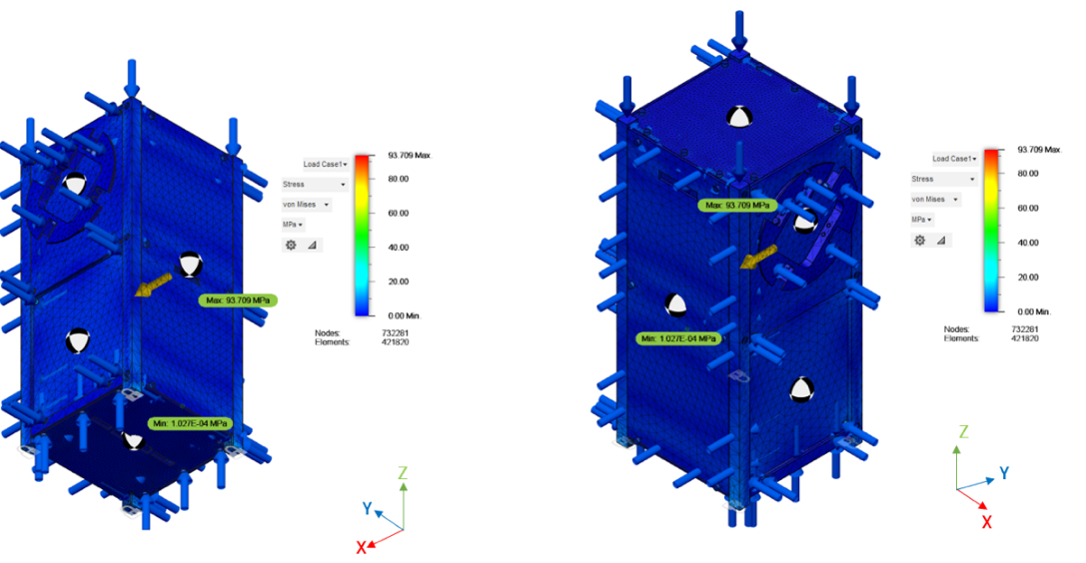

**Figure 5.5.2-1 Static Analysis Result (STA1)**

**Table 5.5.2-1 Satellite Parts Stresses and Margin of Safety for X-axis (STA1)**

|  |  |  |  |  |  |  |  |
| --- | --- | --- | --- | --- | --- | --- | --- |
| **Part** | **Material** | **Max Stress (Smax) [MPa]** | **Yield strength [MPa]** | **Ultimate Strength, Ftu [MPa]** | **MS (Yield)** | **MS (Ultimate)** | **Smax/Ftu [%]** |
| **FS = 1.5** | **FS = 2** | **< 30** |
| Structure-01 | A6061-T6 | 11.3 | 276 | 310 | 15.3 | 12.7 | 3.6 |
| Structure-02 | A6061-T6 | 9.1 | 276 | 310 | 19.2 | 16.0 | 2.9 |
| Structure-03 | A6061-T6 | 7.1 | 276 | 310 | 24.9 | 20.8 | 2.3 |
| Structure-04 | A6061-T6 | 18.6 | 276 | 310 | 8.9 | 7.3 | 6.0 |
| Structure-05 | A6061-T6 | 13.9 | 276 | 310 | 12.2 | 10.2 | 4.5 |
| Structure-06 | A6061-T6 | 8.1 | 276 | 310 | 21.7 | 18.1 | 2.6 |
| Structure-07 | A6061-T6 | 9.4 | 276 | 310 | 18.6 | 15.5 | 3.0 |
| Structure-08 | A6061-T6 | 26.4 | 276 | 310 | 5.9 | 4.9 | 8.5 |
| +Z Panel | FR4 | 1.1 | - | 270 | - | 121.7 | - |
| -Z Panel | FR4 | 1.7 | - | 270 | - | 78.4 | - |
| -Y/-Z Panel (Antenna 1) | FR4 | 5.2 | - | 270 | - | 25.0 | - |
| -Y/+Z Panel | FR4 | 1.2 | - | 270 | - | 111.5 | - |
| +Y/+Z Panel (Antenna 2) | FR4 | 1.7 | - | 270 | - | 78.4 | - |
| +Y/-Z Panel | FR4 | 2.8 | - | 270 | - | 47.2 | - |
| +X Panel | FR4 | 1.5 | - | 270 | - | 89.0 | - |
| -X Panel | FR4 | 1.4 | - | 270 | - | 95.4 | - |
| -Y Cover | FR4 | 1.1 | - | 270 | - | 121.7 | - |
| +Y Cover | FR4 | 1.6 | - | 270 | - | 83.4 | - |
| Component-07 | Teflon | 0.3 | - | 27.5 | - | 44.8 | - |
| Component-25 | Teflon | 0.8 | - | 27.5 | - | 16.2 | - |

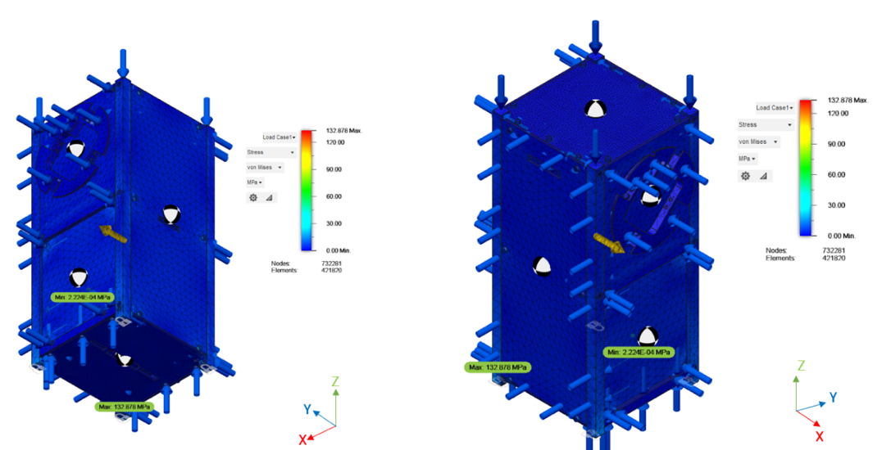

**Figure 5.5.2-2 Static Analysis Result (STA2)**

**Table 5.5.2-2 Satellite Parts Stresses and Margin of Safety Y-axis (STA2)**

|  |  |  |  |  |  |  |  |
| --- | --- | --- | --- | --- | --- | --- | --- |
| **Part** | **Material** | **Max Stress (Smax) [MPa]** | **Yield strength [MPa]** | **Ultimate Strength, Ftu [MPa]** | **MS (Yield)** | **MS (Ultimate)** | **Smax/Ftu [%]** |
| **FS = 1.5** | **FS = 2** | **< 30** |
| Structure-01 | A6061-T6 | 9.8 | 276 | 310 | 17.8 | 14.8 | 3.2 |
| Structure-02 | A6061-T6 | 7.9 | 276 | 310 | 22.3 | 18.6 | 2.5 |
| Structure-03 | A6061-T6 | 6.3 | 276 | 310 | 28.2 | 23.6 | 2.0 |
| Structure-04 | A6061-T6 | 15.2 | 276 | 310 | 11.1 | 9.2 | 4.9 |
| Structure-05 | A6061-T6 | 14.6 | 276 | 310 | 11.6 | 9.6 | 4.7 |
| Structure-06 | A6061-T6 | 8.8 | 276 | 310 | 19.9 | 16.6 | 2.8 |
| Structure-07 | A6061-T6 | 12.1 | 276 | 310 | 14.2 | 11.8 | 3.9 |
| Structure-08 | A6061-T6 | 33.2 | 276 | 310 | 4.5 | 3.7 | 10.7 |
| +Z Panel | FR4 | 1.1 | - | 270 | - | 121.7 | - |
| -Z Panel | FR4 | 2.2 | - | 270 | - | 60.4 | - |
| -Y/-Z Panel (Antenna 1) | FR4 | 4.9 | - | 270 | - | 26.6 | - |
| -Y/+Z Panel | FR4 | 2.9 | - | 270 | - | 45.6 | - |
| +Y/+Z Panel (Antenna 2) | FR4 | 1.7 | - | 270 | - | 78.4 | - |
| +Y/-Z Panel | FR4 | 3.1 | - | 270 | - | 42.5 | - |
| +X Panel | FR4 | 1.8 | - | 270 | - | 74.0 | - |
| -X Panel | FR4 | 3.1 | - | 270 | - | 42.5 | - |
| -Y Cover | FR4 | 1.1 | - | 270 | - | 121.7 | - |
| +Y Cover | FR4 | 1.6 | - | 270 | - | 83.4 | - |
| Component-07 | Teflon | 0.3 | - | 27.5 | - | 44.8 | - |
| Component-25 | Teflon | 0.9 | - | 27.5 | - | 14.3 | - |

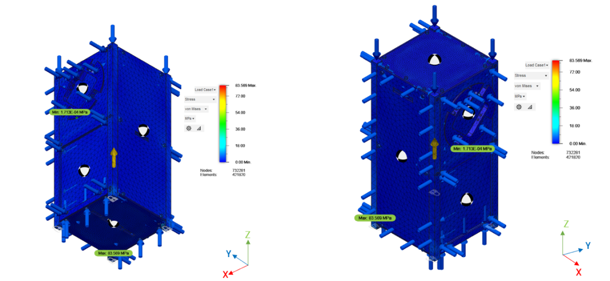

**Figure 5.5.2-3 Static Analysis Result (STA3)**

**Table 5.5.2-3 Satellite Parts Stresses and Margin of Safety Z-axis (STA3)**

|  |  |  |  |  |  |  |  |
| --- | --- | --- | --- | --- | --- | --- | --- |
| **Part** | **Material** | **Max Stress (Smax) [MPa]** | **Yield strength [MPa]** | **Ultimate Strength, Ftu [MPa]** | **MS (Yield)** | **MS (Ultimate)** | **Smax/Ftu [%]** |
| **FS = 1.5** | **FS = 2** | **< 30** |
| Structure-01 | A6061-T6 | 9.4 | 276 | 310 | 18.6 | 15.5 | 3.0 |
| Structure-02 | A6061-T6 | 4.7 | 276 | 310 | 38.1 | 32.0 | 1.5 |
| Structure-03 | A6061-T6 | 7.0 | 276 | 310 | 25.3 | 21.1 | 2.3 |
| Structure-04 | A6061-T6 | 17.2 | 276 | 310 | 9.7 | 8.0 | 5.5 |
| Structure-05 | A6061-T6 | 14.1 | 276 | 310 | 12.0 | 10.0 | 4.5 |
| Structure-06 | A6061-T6 | 8.4 | 276 | 310 | 20.9 | 17.5 | 2.7 |
| Structure-07 | A6061-T6 | 7.4 | 276 | 310 | 23.9 | 19.9 | 2.4 |
| Structure-08 | A6061-T6 | 27.7 | 276 | 310 | 5.64 | 4.60 | 8.94 |
| +Z Panel | FR4 | 1.1 | - | 270 | - | 121.7 | - |
| -Z Panel | FR4 | 1.7 | - | 270 | - | 78.4 | - |
| -Y/-Z Panel (Antenna 1) | FR4 | 5.2 | - | 270 | - | 25.0 | - |
| -Y/+Z Panel | FR4 | 0.7 | - | 270 | - | 191.9 | - |
| +Y/+Z Panel (Antenna 2) | FR4 | 1.7 | - | 270 | - | 78.4 | - |
| +Y/-Z Panel | FR4 | 0.8 | - | 270 | - | 167.8 | - |
| +X Panel | FR4 | 1.2 | - | 270 | - | 111.5 | - |
| -X Panel | FR4 | 1.5 | - | 270 | - | 89.0 | - |
| -Y Cover | FR4 | 1.1 | - | 270 | - | 121.7 | - |
| +Y Cover | FR4 | 1.5 | - | 270 | - | 89.0 | - |
| Component-07 | Teflon | 0.2 | - | 27.5 | - | 67.8 | - |
| Component-25 | Teflon | 1.0 | - | 27.5 | - | 12.8 | - |

Tables 5.5.2-1 to 5.5.2-3 show that the outermost structure has an MS of 0 or more. Therefore, the satellite has sufficient strength to withstand the launch load (due to quasi-static acceleration).

### 5.5.3. Fastener Analysis

All screws used in the structure are hexagon socket screws. Three size was used, M1.6, M2 and M2 ultra-low head screws made of SUS304. The stress at the joints is estimated from the CAD static analysis, and the factor of safety is computed. Fail-safe analysis was done in two cases for each axis, as shown in Table 5.5.3-1. The screws used in the structures are shown in Table 5.5.3-2. The analysis results are shown in Tables 5.5.3-3 to 5.5.3-8.

$$Preload Stress (Q)=\frac{F}{A}=\frac{Axial Load }{πr^{2}}$$

$$MS=\frac{Allowable Stress}{External Stress∙n∙ϕ∙FS+Preload}-1≥0$$

where

$n$ is load-introduction factor = 1;

$ϕ$ is stiffness factor = 1.

**Table 5.5.3-1 Fail Safe Analysis**

|  |  |  |  |
| --- | --- | --- | --- |
| **Case** | **Axis** | **Nominal or one bolt missing per group\*** | **Table** |
| STA1 | X | Nominal | 5.5.3-3 |
| One bolt missing per group | 5.5.3-6 |
| STA2 | Y | Nominal | 5.5.3-4 |
| One bolt missing per group | 5.5.3-7 |
| STA3 | Z | Nominal | 5.5.3-5 |
| One bolt missing per group | 5.5.3-8 |

**Table 5.5.3-2 Screws in Analysis Model**

|  |  |  |  |  |  |  |
| --- | --- | --- | --- | --- | --- | --- |
| **No.** | **ID** | **Location** | **Type** | **Material** | **Initial Torque**  **[Nm]** | **Secondary Locking Feature** |
| 1-1 | ZP-1 | Plus Z panel 1 | M2 | SUS304 | 0.176 | Loctite263 |
| 1-2 | ZP-2 | Plus Z panel 2 | M2 | SUS304 | 0.176 | Loctite263 |
| 1-3 | ZP-3 | Plus Z panel 3 | M2 | SUS304 | 0.176 | Loctite263 |
| 1-4 | ZP-4 | Plus Z panel 4 | M2 | SUS304 | 0.176 | Loctite263 |
| 1-5 | ZP-5 | Plus Z panel 5 | M2 | SUS304 | 0.176 | Loctite263 |
| 1-6 | ZP-6 | Plus Z panel 6 | M2 | SUS304 | 0.176 | Loctite263 |
| 1-7 | ZP-7 | Plus Z panel 7 | M2 | SUS304 | 0.176 | Loctite263 |
| 1-8 | ZP-8 | Plus Z panel 8 | M2 | SUS304 | 0.176 | Loctite263 |
| 1-9 | ZP-9 | Plus Z panel 9 | M2 | SUS304 | 0.176 | Loctite263 |
| 1-10 | ZP-10 | Plus Z panel 10 | M2 | SUS304 | 0.176 | Loctite263 |
| 2-1 | ZM-1 | Minus Z panel 1 | M2 | SUS304 | 0.176 | Loctite263 |
| 2-2 | ZM-2 | Minus Z panel 2 | M2 | SUS304 | 0.176 | Loctite263 |
| 2-3 | ZM-3 | Minus Z panel 3 | M2 | SUS304 | 0.176 | Loctite263 |
| 2-4 | ZM-4 | Minus Z panel 4 | M2 | SUS304 | 0.176 | Loctite263 |
| 2-5 | ZM-5 | Minus Z panel 5 | M2 | SUS304 | 0.176 | Loctite263 |
| 2-6 | ZM-6 | Minus Z panel 6 | M2 | SUS304 | 0.176 | Loctite263 |
| 3-1 | XP-1 | Plus X panel 1 | M2 | SUS304 | 0.176 | Loctite263 |
| 3-2 | XP-2 | Plus X panel 2 | M2 | SUS304 | 0.176 | Loctite263 |
| 3-3 | XP-3 | Plus X panel 3 | M2 | SUS304 | 0.176 | Loctite263 |
| 3-4 | XP-4 | Plus X panel 4 | M2 | SUS304 | 0.176 | Loctite263 |
| 3-5 | XP-5 | Plus X panel 5 | M2 | SUS304 | 0.176 | Loctite263 |
| 3-6 | XP-6 | Plus X panel 6 | M2 | SUS304 | 0.176 | Loctite263 |
| 4-1 | XM-1 | Minus X panel 1 | M2 | SUS304 | 0.176 | Loctite263 |
| 4-2 | XM-2 | Minus X panel 2 | M2 | SUS304 | 0.176 | Loctite263 |
| 4-3 | XM-3 | Minus X panel 3 | M2 | SUS304 | 0.176 | Loctite263 |
| 4-4 | XM-4 | Minus X panel 4 | M2 | SUS304 | 0.176 | Loctite263 |
| 4-5 | XM-5 | Minus X panel 5 | M2 | SUS304 | 0.176 | Loctite263 |
| 4-6 | XM-6 | Minus X panel 6 | M2 | SUS304 | 0.176 | Loctite263 |
| 5-1 | YAP-1 | Plus Y (antenna) side 1 | M2 ultra-low head | SUS304 | 0.16 | Loctite263 |
| 5-2 | YAP-2 | Plus Y (antenna) side 2 | M2 ultra-low head | SUS304 | 0.16 | Loctite263 |
| 5-3 | YAP-3 | Plus Y (antenna) side 3 | M2 ultra-low head | SUS304 | 0.16 | Loctite263 |
| 5-4 | YAP-4 | Plus Y (antenna) side 4 | M2 ultra-low head | SUS304 | 0.16 | Loctite263 |
| 5-5 | YAP-5 | Plus Y (antenna) side 5 (Heat cutter) | M2 | SUS304 | 0.176 | Loctite263 |
| 5-6 | YAP-6 | Plus Y (antenna) side 6 (Heat cutter) | M2 | SUS304 | 0.176 | Loctite263 |
| 6-1 | YMP-1 | Plus Y (Mechanism) side 1 | M2 | SUS304 | 0.176 | Loctite263 |
| 6-2 | YMP-2 | Plus Y (Mechanism) side 2 | M2 | SUS304 | 0.176 | Loctite263 |
| 6-3 | YMP-3 | Plus Y (Mechanism) side 3 | M2 | SUS304 | 0.176 | Loctite263 |
| 6-4 | YMP-4 | Plus Y (Mechanism) side 4 | M2 | SUS304 | 0.176 | Loctite263 |
| 6-5 | YMP-5 | Plus Y (Mechanism) side 5 (Antenna holder) | M2 | SUS304 | 0.176 | Loctite263 |
| 6-6 | YMP-6 | Plus Y (Mechanism) side 6 (Antenna holder) | M2 | SUS304 | 0.176 | Loctite263 |
| 6-7 | YMP-7 | Plus Y (Mechanism) side 7 (Antenna holder) | M2 | SUS304 | 0.176 | Loctite263 |
| 6-8 | YMP-8 | Plus Y (Mechanism) side 8 (Antenna holder) | M2 | SUS304 | 0.176 | Loctite263 |
| 6-9 | YMP-9 | Plus Y (Mechanism) side 9 (Antenna holder) | M2 | SUS304 | 0.176 | Loctite263 |
| 6-10 | YMP-10 | Plus Y (Mechanism) side 10 (Antenna holder) | M2 | SUS304 | 0.176 | Loctite263 |
| 6-11 | YMP-11 | Plus Y (Mechanism) side 11 (Antenna holder) | M2 | SUS304 | 0.176 | Loctite263 |
| 6-12 | YMP-12 | Plus Y (Mechanism) side 12 (Antenna holder) | M2 | SUS304 | 0.176 | Loctite263 |
| 6-13 | YMP-13 | Plus Y (Mechanism) side 13 (Antenna holder) | M2 Nut | SUS304 | 0.176 | Loctite263 |
| 6-14 | YMP-14 | Plus Y (Mechanism) side 14 (Antenna holder) | M2 Nut | SUS304 | 0.176 | Loctite263 |
| 6-15 | YMP-15 | Plus Y (Mechanism) side 15 (Antenna holder) | M2 Nut | SUS304 | 0.176 | Loctite263 |
| 6-16 | YMP-16 | Plus Y (Mechanism) side 16 (Antenna holder) | M2 Nut | SUS304 | 0.176 | Loctite263 |
| 6-17 | YMP-17 | Plus Y (Mechanism) side 17 (Antenna holder) | M2 Nut | SUS304 | 0.176 | Loctite263 |
| 6-18 | YMP-18 | Plus Y (Mechanism) side 18 (Antenna holder) | M2 Nut | SUS304 | 0.176 | Loctite263 |
| 6-19 | YMP-19 | Plus Y (Mechanism) side 19 (Antenna holder) | M2 Nut | SUS304 | 0.176 | Loctite263 |
| 6-20 | YMP-20 | Plus Y (Mechanism) side 29 (Antenna holder) | M2 Nut | SUS304 | 0.176 | Loctite263 |
| 7-1 | YP-1 | Plus Y side 1 | M2 | SUS304 | 0.176 | Loctite263 |
| 7-2 | YP-2 | Plus Y side 2 | M2 | SUS304 | 0.176 | Loctite263 |
| 7-3 | YP-3 | Plus Y side 3 | M2 | SUS304 | 0.176 | Loctite263 |
| 7-4 | YP-4 | Plus Y side 4 | M2 | SUS304 | 0.176 | Loctite263 |
| 8-1 | YCP-1 | Plus Y (Cover) side 1 | M2 ultra-low head | SUS304 | 0.16 | Loctite263 |
| 8-2 | YCP-2 | Plus Y (Cover) side 2 | M2 ultra-low head | SUS304 | 0.16 | Loctite263 |
| 9-1 | YAM-1 | Minus Y (antenna) side 1 | M2 ultra-low head | SUS304 | 0.16 | Loctite263 |
| 9-2 | YAM-2 | Minus Y (antenna) side 2 | M2 ultra-low head | SUS304 | 0.16 | Loctite263 |
| 9-3 | YAM-3 | Minus Y (antenna) side 3 | M2 ultra-low head | SUS304 | 0.16 | Loctite263 |
| 9-4 | YAM-4 | Minus Y (antenna) side 4 | M2 ultra-low head | SUS304 | 0.16 | Loctite263 |
| 9-5 | YAM-5 | Minus Y (antenna) side 5 (Heat cutter) | M2 | SUS304 | 0.176 | Loctite263 |
| 9-6 | YAM-6 | Minus Y (antenna) side 6 (Heat cutter) | M2 | SUS304 | 0.176 | Loctite263 |
| 10-1 | YMM-1 | Minus Y (Mechanism) side 1 | M2 | SUS304 | 0.176 | Loctite263 |
| 10-2 | YMM-2 | Minus Y (Mechanism) side 2 | M2 | SUS304 | 0.176 | Loctite263 |
| 10-3 | YMM-3 | Minus Y (Mechanism) side 3 | M2 | SUS304 | 0.176 | Loctite263 |
| 10-4 | YMM-4 | Minus Y (Mechanism) side 4 | M2 | SUS304 | 0.176 | Loctite263 |
| 10-5 | YMM-5 | Minus Y (Mechanism) side 5 (Antenna holder) | M2 | SUS304 | 0.176 | Loctite263 |
| 10-6 | YMM-6 | Minus Y (Mechanism) side 6 (Antenna holder) | M2 | SUS304 | 0.176 | Loctite263 |
| 10-7 | YMM-7 | Minus Y (Mechanism) side 7 (Antenna holder) | M2 | SUS304 | 0.176 | Loctite263 |
| 10-8 | YMM-8 | Minus Y (Mechanism) side 8 (Antenna holder) | M2 | SUS304 | 0.176 | Loctite263 |
| 10-9 | YMM-9 | Minus Y (Mechanism) side 9 (Antenna holder) | M2 | SUS304 | 0.176 | Loctite263 |
| 10-10 | YMM-10 | Minus Y (Mechanism) side 10 (Antenna holder) | M2 | SUS304 | 0.176 | Loctite263 |
| 10-11 | YMM-11 | Minus Y (Mechanism) side 11 (Antenna holder) | M2 | SUS304 | 0.176 | Loctite263 |
| 10-12 | YMM-12 | Minus Y (Mechanism) side 12 (Antenna holder) | M2 | SUS304 | 0.176 | Loctite263 |
| 10-13 | YMP-13 | Minus Y (Mechanism) side 13 (Antenna holder) | M2 Nut | SUS304 | 0.176 | Loctite263 |
| 10-14 | YMP-14 | Minus Y (Mechanism) side 14 (Antenna holder) | M2 Nut | SUS304 | 0.176 | Loctite263 |
| 10-15 | YMP-15 | Minus Y (Mechanism) side 15 (Antenna holder) | M2 Nut | SUS304 | 0.176 | Loctite263 |
| 10-16 | YMP-16 | Minus Y (Mechanism) side 16 (Antenna holder) | M2 Nut | SUS304 | 0.176 | Loctite263 |
| 10-17 | YMP-17 | Minus Y (Mechanism) side 17 (Antenna holder) | M2 Nut | SUS304 | 0.176 | Loctite263 |
| 10-18 | YMP-18 | Minus Y (Mechanism) side 18 (Antenna holder) | M2 Nut | SUS304 | 0.176 | Loctite263 |
| 10-19 | YMP-19 | Minus Y (Mechanism) side 19 (Antenna holder) | M2 Nut | SUS304 | 0.176 | Loctite263 |
| 10-20 | YMP-20 | Minus Y (Mechanism) side 29 (Antenna holder) | M2 Nut | SUS304 | 0.176 | Loctite263 |
| 11-1 | YM-1 | Minus Y side 1 | M2 | SUS304 | 0.176 | Loctite263 |
| 11-2 | YM-2 | Minus Y side 2 | M2 | SUS304 | 0.176 | Loctite263 |
| 11-3 | YM-3 | Minus Y side 3 | M2 | SUS304 | 0.176 | Loctite263 |
| 11-4 | YM-4 | Minus Y side 4 | M2 | SUS304 | 0.176 | Loctite263 |
| 12-1 | YCM-1 | Minus Y (Cover) side 1 | M2 ultra-low head | SUS304 | 0.160 | Loctite263 |
| 12-2 | YCM-2 | Minus Y (Cover) side 2 | M2 ultra-low head | SUS304 | 0.160 | Loctite263 |
| 13-1 | MS-1 | Structure 1 | M2 | SUS304 | 0.176 | Loctite263 |
| 13-2 | MS-2 | Structure 2 | M2 | SUS304 | 0.176 | Loctite263 |
| 13-3 | MS-3 | Structure 3 | M2 | SUS304 | 0.176 | Loctite263 |
| 13-4 | MS-4 | Structure 4 | M2 | SUS304 | 0.176 | Loctite263 |
| 13-5 | MS-5 | Structure 5 | M2 | SUS304 | 0.176 | Loctite263 |
| 13-6 | MS-6 | Structure 6 | M2 | SUS304 | 0.176 | Loctite263 |
| 13-7 | MS-7 | Structure 7 | M2 | SUS304 | 0.176 | Loctite263 |
| 13-8 | MS-8 | Structure 8 | M2 | SUS304 | 0.176 | Loctite263 |
| 13-9 | MS-9 | Structure 9 | M2 | SUS304 | 0.176 | Loctite263 |
| 13-10 | MS-10 | Structure 10 | M2 | SUS304 | 0.176 | Loctite263 |
| 13-11 | MS-11 | Structure 11 | M2 | SUS304 | 0.176 | Loctite263 |
| 13-12 | MS-12 | Structure 12 | M2 | SUS304 | 0.176 | Loctite263 |
| 13-13 | MS-13 | Structure 13 | M2 | SUS304 | 0.176 | Loctite263 |
| 14-1 | DS-1 | Deployment Switch 1 | M1.6 | SUS304 | 0.086 | Loctite263 |
| 14-2 | DS-2 | Deployment Switch 2 | M1.6 | SUS304 | 0.086 | Loctite263 |
| 14-3 | DS-3 | Deployment Switch 3 | M1.6 | SUS304 | 0.086 | Loctite263 |

**Figure 5.5.3-1 Screws on the +Z Panel**

**Figure 5.5.3-2 Screws on the -Z Panel**

**Figure 5.5.3-3 Screws on the +X Panel**

**Figure 5.5.3-4 Screws on the -X Panel**

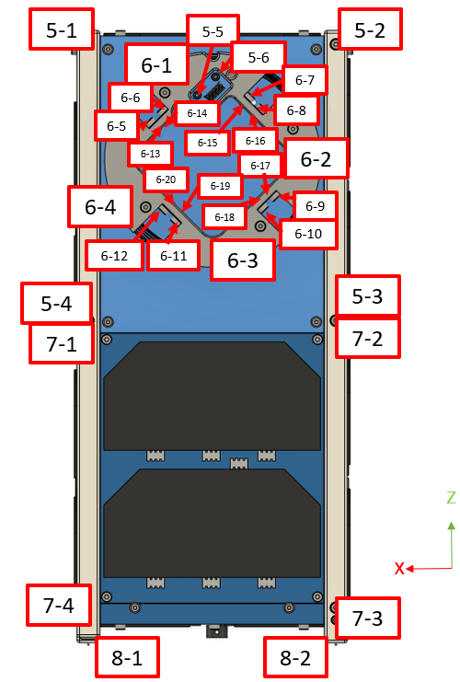

**Figure 5.5.3-5 Screws on the +Y Panel**

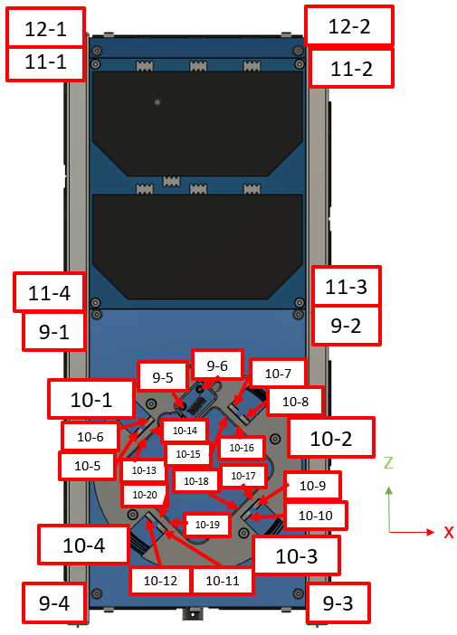

**Figure 5.5.3-6 Screws on the -Y Panel**

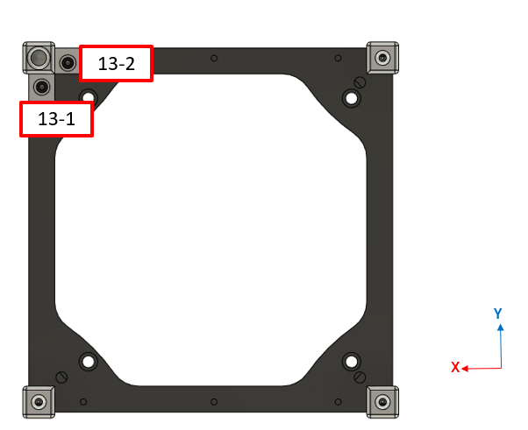

**Figure 5.5.3-7 Screws of Structure 01**

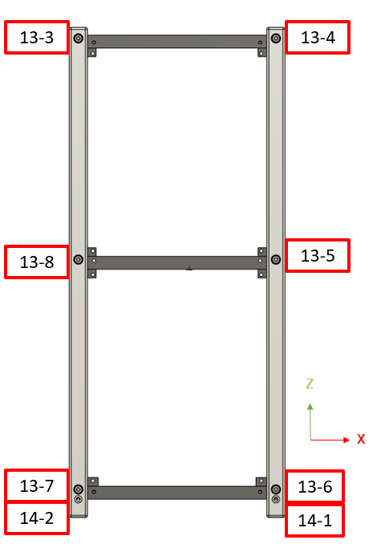

**Figure 5.5.3-8 Screws of Structure 02**

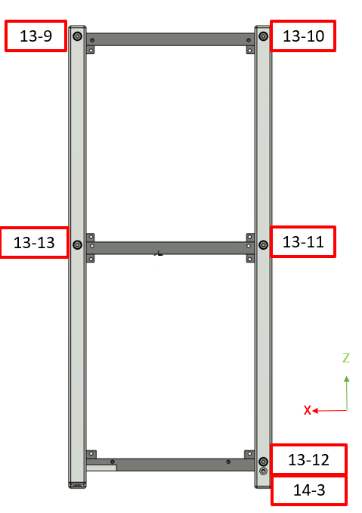

**Figure 5.5.3-9 Screws of Structure 03**

**Table 5.5.3-3 Fastener Analysis Result for Nominal Case X-axis (STA1)**

|  |  |  |  |  |  |  |  |
| --- | --- | --- | --- | --- | --- | --- | --- |
| **No.** | **Group Name** | **Pre-load Stress [MPa]** | **External Stress [MPa]** | **Ultimate Strength [MPa]** | **MS (FS=2)** | **Screw No. with Max Stress (Table 5.5.3-2)** | **NDE Required?** |
| 1 | Bolt: +X Panel | 213 | 15.1 | 505 | 1.1 | 3-6 | No |
| 2 | Bolt: -X Panel | 213 | 14.8 | 505 | 1.1 | 4-6 | No |
| 3 | Bolt: +Y Panel | 213 | 40.9 | 505 | 0.7 | 7-3 | No |
| 4 | Bolt: +Y Antenna Panel | 193 | 41.7 | 505 | 0.8 | 5-1 | No |
| 5 | Bolt: +Y Mechanism | 213 | 33.1 | 505 | 0.8 | 6-1 | No |
| 6 | Bolt: +Y Cover | 193 | 29.9 | 505 | 1.0 | 8-2 | No |
| 7 | Bolt: -Y Panel | 213 | 17.3 | 505 | 1.0 | 11-2 | No |
| 8 | Bolt: -Y Antenna Panel | 193 | 77.5 | 505 | 0.5 | 9-4 | No |
| 9 | Bolt: -Y Mechanism | 213 | 45.7 | 505 | 0.7 | 10-4 | No |
| 10 | Bolt: -Y Cover | 193 | 25.1 | 505 | 1.1 | 12-2 | No |
| 11 | Bolt: +Z Panel | 213 | 7.5 | 505 | 1.2 | 1-2 | No |
| 12 | Bolt: -Z Panel | 213 | 12.2 | 505 | 1.1 | 2-4 | No |
| 13 | Main Structure | 213 | 93.7 | 505 | 0.3 | 13-8 | No |
| 14 | Deployment Switch | 211 | 64.5 | 505 | 0.5 | 14-3 | No |

**Table 5.5.3-4 Fastener Analysis Result for Nominal Case Y-axis (STA2)**

|  |  |  |  |  |  |  |  |
| --- | --- | --- | --- | --- | --- | --- | --- |
| **No.** | **Group Name** | **Pre-load Stress [MPa]** | **External Stress [MPa]** | **Ultimate Strength [MPa]** | **MS (FS=2)** | **Screw No. with Max Stress (Table 5.5.3-2)** | **NDE Required?** |
| 1 | Bolt: +X Panel | 213 | 18.9 | 505 | 1.0 | 3-4 | No |
| 2 | Bolt: -X Panel | 213 | 45.4 | 505 | 0.7 | 4-5 | No |
| 3 | Bolt: +Y Panel | 213 | 18.8 | 505 | 1.0 | 7-2 | No |
| 4 | Bolt: +Y Antenna Panel | 193 | 16.3 | 505 | 1.2 | 5-4 | No |
| 5 | Bolt: +Y Mechanism | 213 | 33.1 | 505 | 0.8 | 6-1 | No |
| 6 | Bolt: +Y Cover | 193 | 30.1 | 505 | 1.0 | 8-2 | No |
| 7 | Bolt: -Y Panel | 213 | 14.5 | 505 | 1.1 | 11-2 | No |
| 8 | Bolt: -Y Antenna Panel | 193 | 40.4 | 505 | 0.8 | 9-1 | No |
| 9 | Bolt: -Y Mechanism | 213 | 47.5 | 505 | 0.6 | 10-3 | No |
| 10 | Bolt: -Y Cover | 193 | 25.2 | 505 | 1.1 | 12-2 | No |
| 11 | Bolt: +Z Panel | 213 | 8 | 505 | 1.2 | 1-10 | No |
| 12 | Bolt: -Z Panel | 213 | 11.9 | 505 | 1.1 | 2-6 | No |
| 13 | Main Structure | 213 | 132.9 | 505 | 0.1 | 13-6 | No |
| 14 | Deployment Switch | 211 | 64.8 | 505 | 0.5 | 14-3 | No |

**Table 5.5.3-5 Fastener Analysis Result for Nominal Case Z-axis (STA3)**

|  |  |  |  |  |  |  |  |
| --- | --- | --- | --- | --- | --- | --- | --- |
| **No.** | **Group Name** | **Pre-load Stress [MPa]** | **External Stress [MPa]** | **Ultimate Strength [MPa]** | **MS (FS=2)** | **Screw No. with Max Stress (Table 5.5.3-2)** | **NDE Required?** |
| 1 | Bolt: +X Panel | 213 | 9.4 | 505 | 1.2 | 3-4 | No |
| 2 | Bolt: -X Panel | 213 | 16 | 505 | 1.1 | 4-3 | No |
| 3 | Bolt: +Y Panel | 213 | 13.3 | 505 | 1.1 | 7-4 | No |
| 4 | Bolt: +Y Antenna Panel | 193 | 16.6 | 505 | 1.2 | 5-4 | No |
| 5 | Bolt: +Y Mechanism | 213 | 33.2 | 505 | 0.8 | 6-1 | No |
| 6 | Bolt: +Y Cover | 193 | 29.8 | 505 | 1.0 | 8-2 | No |
| 7 | Bolt: -Y Panel | 213 | 13.8 | 505 | 1.1 | 11-2 | No |
| 8 | Bolt: -Y Antenna Panel | 193 | 17.1 | 505 | 1.2 | 9-2 | No |
| 9 | Bolt: -Y Mechanism | 213 | 43.5 | 505 | 0.7 | 10-3 | No |
| 10 | Bolt: -Y Cover | 193 | 25 | 505 | 1.1 | 12-2 | No |
| 11 | Bolt: +Z Panel | 213 | 7.7 | 505 | 1.2 | 1-4 | No |
| 12 | Bolt: -Z Panel | 213 | 11.8 | 505 | 1.1 | 2-4 | No |
| 13 | Main Structure | 213 | 83.6 | 505 | 0.3 | 13-6 | No |
| 14 | Deployment Switch | 211 | 65 | 505 | 0.5 | 14-3 | No |

**Table 5.5.3-6 One-Bolt Missing Analysis X-axis (STA1)**

|  |  |  |  |  |  |  |  |  |  |
| --- | --- | --- | --- | --- | --- | --- | --- | --- | --- |
| **No.** | **Group Name** | **Pre-load Stress [MPa]** | **External Stress [MPa]** | **Ultimate Strength [MPa]** | **MS (FS = 1)** | **Screw No. with Max Stress (Table 5.5.3-2)** | **Removed Screw No. (Table 5.5.3-2)** | **Number of bolts in nominal configuration** | **NDE Required?** |
| 1 | Bolt: +X Panel | 213 | 15.7 | 505 | 1.2 | 3-3 | 3-6 | 6 | No |
| 2 | Bolt: -X Panel | 213 | 22 | 505 | 1.1 | 4-4 | 4-6 | 6 | No |
| 3 | Bolt: +Y Panel | 213 | 58.2 | 505 | 0.9 | 7-2 | 7-3 | 4 | No |
| 4 | Bolt: +Y Antenna Panel | 193 | 78.7 | 505 | 0.9 | 5-4 | 5-1 | 6 | No |
| 5 | Bolt: +Y Mechanism | 213 | 37.1 | 505 | 1.0 | 6-3 | 6-1 | 12 | No |
| 6 | Bolt: +Y Cover | 193 | 41.4 | 505 | 1.2 | 8-1 | 8-2 | 2 | No |
| 7 | Bolt: -Y Panel | 213 | 23.8 | 505 | 1.1 | 11-1 | 11-2 | 4 | No |
| 8 | Bolt: -Y Antenna Panel | 193 | 87.8 | 505 | 0.8 | 9-3 | 9-4 | 6 | No |
| 9 | Bolt: -Y Mechanism | 213 | 81.8 | 505 | 0.7 | 10-3 | 10-4 | 12 | No |
| 10 | Bolt: -Y Cover | 193 | 32.4 | 505 | 1.2 | 12-1 | 12-2 | 2 | No |
| 11 | Bolt: +Z Panel | 213 | 8.2 | 505 | 1.3 | 1-4 | 1-2 | 10 | No |
| 12 | Bolt: -Z Panel | 213 | 14.8 | 505 | 1.2 | 2-6 | 2-4 | 6 | No |
| 13 | Main Structure | 213 | 218.4 | 505 | 0.2 | 13-11 | 13-8 | 13 | No |

**Table 5.5.3-7 One-Bolt Missing Analysis Y-axis (STA2)**

|  |  |  |  |  |  |  |  |  |  |
| --- | --- | --- | --- | --- | --- | --- | --- | --- | --- |
| **No.** | **Group Name** | **Pre-load Stress [MPa]** | **External Stress [MPa]** | **Ultimate Strength [MPa]** | **MS (FS = 1)** | **Screw No. with Max Stress (Table 5.5.3-2)** | **Removed Screw No. (Table 5.5.3-2)** | **Number of bolts in nominal configuration** | **NDE Required?** |
| 1 | Bolt: +X Panel | 213 | 19.1 | 505 | 1.2 | 3-5 | 3-4 | 6 | No |
| 2 | Bolt: -X Panel | 213 | 56.9 | 505 | 0.9 | 4-4 | 4-5 | 6 | No |
| 3 | Bolt: +Y Panel | 213 | 16.6 | 505 | 1.2 | 7-1 | 7-2 | 4 | No |
| 4 | Bolt: +Y Antenna Panel | 193 | 18.7 | 505 | 1.4 | 5-2 | 5-4 | 6 | No |
| 5 | Bolt: +Y Mechanism | 213 | 37.1 | 505 | 1.0 | 6-3 | 6-1 | 12 | No |
| 6 | Bolt: +Y Cover | 193 | 41.9 | 505 | 1.1 | 8-1 | 8-2 | 2 | No |
| 7 | Bolt: -Y Panel | 213 | 17.3 | 505 | 1.2 | 11-1 | 11-2 | 4 | No |
| 8 | Bolt: -Y Antenna Panel | 193 | 32.8 | 505 | 1.2 | 9-2 | 9-1 | 6 | No |
| 9 | Bolt: -Y Mechanism | 213 | 75.4 | 505 | 0.8 | 10-4 | 10-3 | 12 | No |
| 10 | Bolt: -Y Cover | 193 | 32.5 | 505 | 1.2 | 12-1 | 12-2 | 2 | No |
| 11 | Bolt: +Z Panel | 213 | 8.4 | 505 | 1.3 | 1-4 | 1-10 | 10 | No |
| 12 | Bolt: -Z Panel | 213 | 14 | 505 | 1.2 | 2-4 | 2-6 | 6 | No |
| 13 | Main Structure | 213 | 138 | 505 | 0.4 | 13-11 | 13-6 | 13 | No |

**Table 5.5.3-8 One-Bolt Missing Analysis Z-axis (STA3)**

|  |  |  |  |  |  |  |  |  |  |
| --- | --- | --- | --- | --- | --- | --- | --- | --- | --- |
| **No.** | **Group Name** | **Pre-load Stress [MPa]** | **External Stress [MPa]** | **Ultimate Strength [MPa]** | **MS (FS = 1)** | **Screw No. with Max Stress (Table 5.5.3-2)** | **Removed Screw No. (Table 5.5.3-2)** | **Number of bolts in nominal configuration** | **NDE Required?** |
| 1 | Bolt: +X Panel | 213 | 10.6 | 505 | 1.3 | 3-5 | 3-4 | 6 | No |
| 2 | Bolt: -X Panel | 213 | 18.4 | 505 | 1.2 | 4-4 | 4-3 | 6 | No |
| 3 | Bolt: +Y Panel | 213 | 17.1 | 505 | 1.2 | 7-1 | 7-4 | 4 | No |
| 4 | Bolt: +Y Antenna Panel | 193 | 19.1 | 505 | 1.4 | 5-1 | 5-4 | 6 | No |
| 5 | Bolt: +Y Mechanism | 213 | 37.2 | 505 | 1.0 | 6-3 | 6-1 | 12 | No |
| 6 | Bolt: +Y Cover | 193 | 42 | 505 | 1.1 | 8-1 | 8-2 | 2 | No |
| 7 | Bolt: -Y Panel | 213 | 16.2 | 505 | 1.2 | 11-1 | 11-2 | 4 | No |
| 8 | Bolt: -Y Antenna Panel | 193 | 22 | 505 | 1.3 | 9-3 | 9-2 | 6 | No |
| 9 | Bolt: -Y Mechanism | 213 | 60.8 | 505 | 0.8 | 10-4 | 10-3 | 12 | No |
| 10 | Bolt: -Y Cover | 193 | 32.9 | 505 | 1.2 | 12-1 | 12-2 | 2 | No |
| 11 | Bolt: +Z Panel | 213 | 8 | 505 | 1.3 | 1-3 | 1-4 | 10 | No |
| 12 | Bolt: -Z Panel | 213 | 14.3 | 505 | 1.2 | 2-6 | 2-4 | 6 | No |
| 13 | Main Structure | 213 | 89.3 | 505 | 0.7 | 13-5 | 13-6 | 13 | No |

# Structure Fracture Control

## Potentially Fracture Critical Parts Identification

Screening of safety-critical structures and fracture control classification is performed in accordance with JMX-2011303E. Safety-critical structures 2U are summarized in Table 6.1-1. As shown in this table, low-risk fracture parts, contained parts, and fail-safe parts are identified.

### Contained Parts

All internal parts of DRAGONFLY are classified as contained parts since they are contained by the most outer structures made of aluminum alloy and panels of FR4 (glass epoxy panels with sufficiently small gaps).

### Fail-Safe Parts

All safety critical bolts are classified as fail-safe parts shown in Table 5.5.3-6 to Table 5.5.3-8, and they are locked by using appropriate liquid –locking compound. After the vibration test, the torque marks of fasteners other than those that do not correspond to the main load path will be inspected visually.

The four outermost antennas (VHF antennas) are each fixed with two independent wires. For the wire to be used, will perform a strength test to confirm the strength, and we will use the wires that are fully stretched (the results will be included in the wire strength test report). The assembly procedure manages the wiring. As wire control to confirm no break or loosen, a vibration test at flight level will be performed (the results are included in the vibration test report).

### Low-Risk Fracture Parts

Low risk fracture parts are listed in Tables 5.5.2-1 to 5.5.2-3. The maximum value of Smax/Ftu evaluated for each part in STA 1 to STA 3 is 6.0% which is smaller than 30%. All low-risk parts will be conducted for visual inspection at least before assembly. After vibration test, a modal survey will be conducted to confirm that the natural frequency of the satellite after vibration test will not prominently be different from the frequency before the vibration test. After vibration test, low risk parts that can be checked for appearance will be subjected to visual inspection. (The results will be included in Vibration test report)

*Refer: SSP52005F/5.3.1.4.2.1/C

### Sealed Container

There is no sealed container in this satellite.

### Fracture Critical Parts

Glasses for solar cells, outer panels made of FR4 and antenna deployment mechanisms made of Teflon are classified as fracture-critical parts. As fracture control of these glass parts and non-metal parts, a vibration test at flight level will be performed. After the vibration test, detailed visual inspection will adequately be implemented to these parts (the results are included in the vibration test report).

### Pressurized System

There is no pressure system in this satellite.

### Pressurized vessel

There is no pressure vessel in this satellite.

### High Energy Rotating Machinery

There is no rotating machinery in this satellite.

## Inspection for Safety Critical Structures

It will be confirmed that there is no non-conformance in the safety-critical structures as a result of the inspection from the part acceptance phase through the assembly phase in accordance with JMX-2011303E.

## Inspection After Test

After the vibration test, it will be confirmed that there is no non-conformance in the safety-critical structures as a result of the inspection in accordance with JMX-2011303E.

# Discrepancy or Anomaly Reports

No discrepancy or anomaly was identified.

# Material Usage Agreements for Stress Corrosion Cracking Material

There is no MUA for DRAGONFLY.

# Conclusions

The structural analysis of DRAGONFLY is completed.

All parts meet the fracture control requirements to ensure no failures occur throughout the life of the DRAGONFLY due to fracture.

**Table 6.1-1: Potentially Fracture Critical Parts Identification List**

| No | Part Name | Part No. | Material | Function | Failure Mode | Effect of Failure*1 | Contained part | Fail Safe Part | Low Risk Fracture Part | Fracture Critical part | Exempt from Fracture Critical | Remarks |
| --- | --- | --- | --- | --- | --- | --- | --- | --- | --- | --- | --- | --- |
| 1 | Frame -Z | Structure-01 | A6061-T6 | structure | tensile  bending | 7 | - | - | **×** | **-** | - | ・Verified with structural Analysis |
| 2 | Frame 0Z | Structure-02 | A6061-T6 | structure | tensile  bending | 7 | - | - | **×** | **-** | - | ・Verified with structural Analysis |
| 3 | Frame +Z | Structure-03 | A6061-T6 | structure | tensile  bending | 7 | - | - | **×** | **-** | - | ・Verified with structural Analysis |
| 4 | Rail (-Y/-X) | Structure-04 | A6061-T6 | structure | tensile  bending | 7 | - | - | **×** | **-** | - | ・Verified with structural Analysis |
| 5 | Rail (+Y/-X) | Structure-05 | A6061-T6 | structure | tensile  bending | 7 | - | - | **×** | **-** | - | ・Verified with structural Analysis |
| 6 | Rail (+Y/+X) | Structure-06 | A6061-T6 | structure | tensile  bending | 7 | - | - | **×** | **-** | - | ・Verified with structural Analysis |
| 7 | Rail (-Y/+X) | Structure-07 | A6061-T6 | structure | tensile  bending | 7 | - | - | **×** | - | - | ・Verified with structural Analysis |
| 8 | +Z Panel | +Z Panel | FR4 | structure | tensile  shear | 7 | - | - | - | **×** | - | ・Vibration test at flight level will be performed.  ・There are many launch records of CubeSats with the FR4 panel as the outermost layer.  ・MS is large based on the results of structural analysis. Stress generated is extremely small compared to material strength. |
| 9 | -Z Panel | -Z Panel | FR4 | structure | tensile  bending | 7 | - | - | - | **×** | - | ・Vibration test at flight level will be performed.  ・There are many launch records of CubeSats with the FR4 panel as the outermost layer.  ・MS is large based on the results of structural analysis. Stress generated is extremely small compared to material strength. |
| 10 | -Y/-Z Panel  (Antenna 1) | -Y/-Z Panel | FR4 | structure | tensile  bending | 7 | - | - | - | **×** | - | ・Vibration test at flight level will be performed.  ・There are many launch records of CubeSats with the FR4 panel as the outermost layer.  ・MS is large based on the results of structural analysis. Stress generated is extremely small compared to material strength. |
| 11 | -Y/+Z Panel | -Y/+Z Panel | FR4 | structure | tensile  bending | 7 | - | - | - | **×** | - | ・Vibration test at flight level will be performed.  ・There are many launch records of CubeSats with the FR4 panel as the outermost layer.  ・MS is large based on the results of structural analysis. Stress generated is extremely small compared to material strength. |
| 12 | +Y/+Z Panel (Antenna 2) | +Y/+Z Panel | FR4 | structure | tensile  bending | 7 | - | - | - | **×** | - | ・Vibration test at flight level will be performed.  ・There are many launch records of CubeSats with the FR4 panel as the outermost layer.  ・MS is large based on the results of structural analysis. Stress generated is extremely small compared to material strength. |
| 13 | +Y/-Z Panel | +Y/-Z Panel | FR4 | structure | tensile  bending | 7 | - | - | - | **×** | - | ・Vibration test at flight level will be performed.  ・There are many launch records of CubeSats with the FR4 panel as the outermost layer.  ・MS is large based on the results of structural analysis. Stress generated is extremely small compared to material strength. |
| 14 | +X Panel | +X Panel | FR4 | structure | tensile  bending | 7 | - | - | - | **×** | - | ・Vibration test at flight level will be performed.  ・There are many launch records of CubeSats with the FR4 panel as the outermost layer.  ・MS is large based on the results of structural analysis. Stress generated is extremely small compared to material strength. |
| 15 | -X Panel | -X Panel | FR4 | structure | tensile  bending | 7 | - | - | - | **×** | - | ・Vibration test at flight level will be performed.  ・There are many launch records of CubeSats with the FR4 panel as the outermost layer.  ・MS is large based on the results of structural analysis. Stress generated is extremely small compared to material strength. |
| 16 | -Y Cover | -Y Cover | FR4 | structure | tensile  bending | 7 | - | - | - | **×** | - | ・Vibration test at flight level will be performed.  ・There are many launch records of CubeSats with the FR4 panel as the outermost layer.  ・MS is large based on the results of structural analysis. Stress generated is extremely small compared to material strength. |
| 17 | +Y Cover | +Y Cover | FR4 | structure | tensile  bending | 7 | - | - | - | **×** | - | ・Vibration test at flight level will be performed.  ・There are many launch records of CubeSats with the FR4 panel as the outermost layer.  ・MS is large based on the results of structural analysis. Stress generated is extremely small compared to material strength. |
| 18 | Battery | Component-01 | NiMH | Mission | - | 2 | **×** | - | - | **-** | - | ・Vibration test at flight level will be performed |
| 19 | Battery Box | Component-02 | A6061-T6 | structure | tensile  bending | 7 | **×** | - | - | **-** | - | ・Vibration test at flight level will be performed |
| 20 | Battery  Box Cover | Component-03 | A6061-T6 | structure | tensile  bending | 7 | **×** | - | - | **-** | - | ・Vibration test at flight level will be performed |
| 21 | Battery Insulator | Component-04 | Teflon | Mission | - | 2 | **×** | - | - | - | - | ・Vibration test at flight level will be performed |
| 22 | Stacking Rod | Component-05 | SUS304 | structure | tensile  bending | 7 | **×** | - | - | - | - | ・Vibration test at flight level will be performed |
| 23 | Spacer | Component-06 | MC Nylon | Mission | - | 2 | **×** | - | - | - | - | ・Vibration test at flight level will be performed |
| 24 | Antenna  deployment mechanism 1 | Component-07 | Teflon | structure | - | 2 | - | - | **-** | **×** | - | ・Vibration test at flight level will be performed.  ・MS is large based on the results of structural analysis. Stress generated is extremely small compared to material strength. |
| 25 | UHF  Antenna | Component-08 | SK85 | structure | tensile  bending | 7 | - | - | **-** | **-** | **×** | ・Vibration test at flight level will be performed |
| 26 | VHF  Antenna | Component-09 | SK85 | structure | tensile  bending | 7 | - | - | **-** | - | **×** | ・Vibration test at flight level will be performed |
| 27 | Internal components | Component-10,11,12,13,14,  15,16,17,18,19,  20,21,22 | FR4 | Mission | - | 2 | **×** | - | - | - | - | ・Vibration test at flight level will be performed |
| 28 | Solar Cell | Component-23 | Glass | Mission | - | 2 | - | - | **-** | **×** | - | ・Vibration test at flight level will be performed |
| 29 | Fastener (Screw) | Fastener-01 | SUS304 | structure | tensile  bending | 7 | - | **×** | **-** | **-** | - | ・Verified with structural Analysis |
| 30 | SLBNR3  (Nut) | Fastener-02 | SUS304 | structure | tensile  bending | 7 | **×** | **-** | **-** | **-** | **-** | ・Vibration test at flight level will be performed |
| 31 | Fishing Wire | Wire | PE line | Mission | - | 7 | - | **×** | **-** | **-** | - | ・Vibration test at flight level will be performed |
| 32 | Heat cutter | Heat cutter | Nichrome | Mission | tensile  bending | 2 | **-** | - | **-** | **-** | **×** | ・Vibration test at flight level will be performed |
| 33 | Antenna  deployment mechanism 2 | Component-24 | Teflon | structure | - | 2 | - | - | **-** | **×** | - | ・Vibration test at flight level will be performed.  ・MS is large based on the results of structural analysis. Stress generated is extremely small compared to material strength. |
| 34 | Deployment Switch Cover (L-shape) | Structure-08 | A6061-T6 | structure | tensile  bending | 7 | - | - | **×** | **-** | - | ・Verified with structural Analysis |
| 35 | Hexagonal Nut M2 | Fastener-03 | SUS304 | Structure | tensile  bending | 7 | - | x | **-** | **-** | - | Verified with structural Analysis  Vibration test at flight level will be performed |

*1: The effect of failure is specified from the number listed below.

1. Hazardous to personnel 2. Hazardous to Flight Crew 3. Hazardous to GSE 4. Hazardous to J-SSOD

5. Hazardous to HTV 6. Hazardous to JEM 7. Hazardous to ISS